Assignment 18

Steffan Nilsson

For this assignment, answer the following exercise questions in the textbook

1. Give the function *g* that is part of the formal definition of the directed graph below.

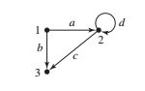

Function g(a) = 1->2, g(b) = 1->3, g(c) = 2->3, g(d) = 2->2

2. Use the graph in the figure to answer the questions that follow.

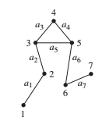

a. The graph is not simple.

b. The graph is not complete.

c. The graph is connected.

d. Two paths from 3 to 6: 3-4-5-6 or 3-5-6

e. Can you find a cycle? 3-4-5-3

f. Remove edge a5 to make the graph not have a cycle.

g. Remove either edge a3 or edge a4 to make the graph not connected.

5. Draw K5.

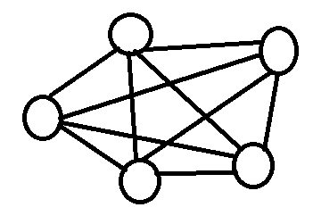

9. An acquaintanceship graph is an undirected graph in which nodes represent people and nodes a and b are adjacent if a and b are acquainted.

a. The acquaintanceship graph for the IT department and the Marketing department of a major corporation is an unconnected graph. What does this imply?

It implies that the two departments rarely if ever interact with one another and are not acquainted with one another.

b. The following figure represents an acquaintanceship graph for residents of an apartment building. Are Carl and Fletcher acquainted? How many people is SiuYin acquainted with?

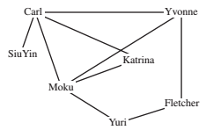

Carl and Fletcher do not know each other, and SiuYin only knows 1 person.

13. Which of the following Graphs are not isomorphic to the others and why?

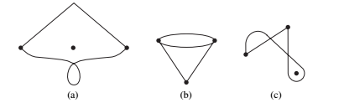

Graph (b) is not isomorphic to graphs (a) and (c) because all three of its vertex are connected to the graph.

30. If all the nodes of a simples connected planar graph have degree 4 and the number of arcs is 12, into how many regions does it divide the plane?

n – a + r = 2 n = 5 a = 12

5 – 12 + r = 2 -> r – 7 = 2 -> **r = 9**

49. Describe the graph whose adjacency matrix is In, the n X n identity matrix.

The graph would consist of number of isolated vertices that all have a loop to themselves and nothing more.

50. Describe the graph whose adjacency matrix is 0n, the n X n matrix of all 0’s.

A graph that consists entirely of isolated vertices, with no edges.

51. Describe the adjacency matrix for Kn, the simple, complete graph with n nodes.

It would have a value of 1 in every slot on the matrix, except those that would note a looping edge.

65. Draw G' for the graph of figure 6.18a.

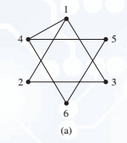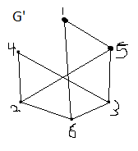

71. Given an adjacency matrix A for a simple graph G, describe the adjacency matrix for G'.